Attack Report
Lab Name: OWASP Juice Shop
Created by: Nilarjo Mazumdar
Threat scenario description, target selection, and attack goals:
All exercises are performed on the OWASP Juice Shop, which is running on Kali Linux 2025.3, accessible at http://localhost:3000/#/.
It presents us with a lot of vulnerabilities to exploit.
In this report, I have specifically exploited a few of the Login involved SQL Injection attacks to escalate privileges and get into the system.
Step-by-step Attack Execution:
- After running http://localhost:3000/#/ on a web browser on Kali. I was presented with this page:
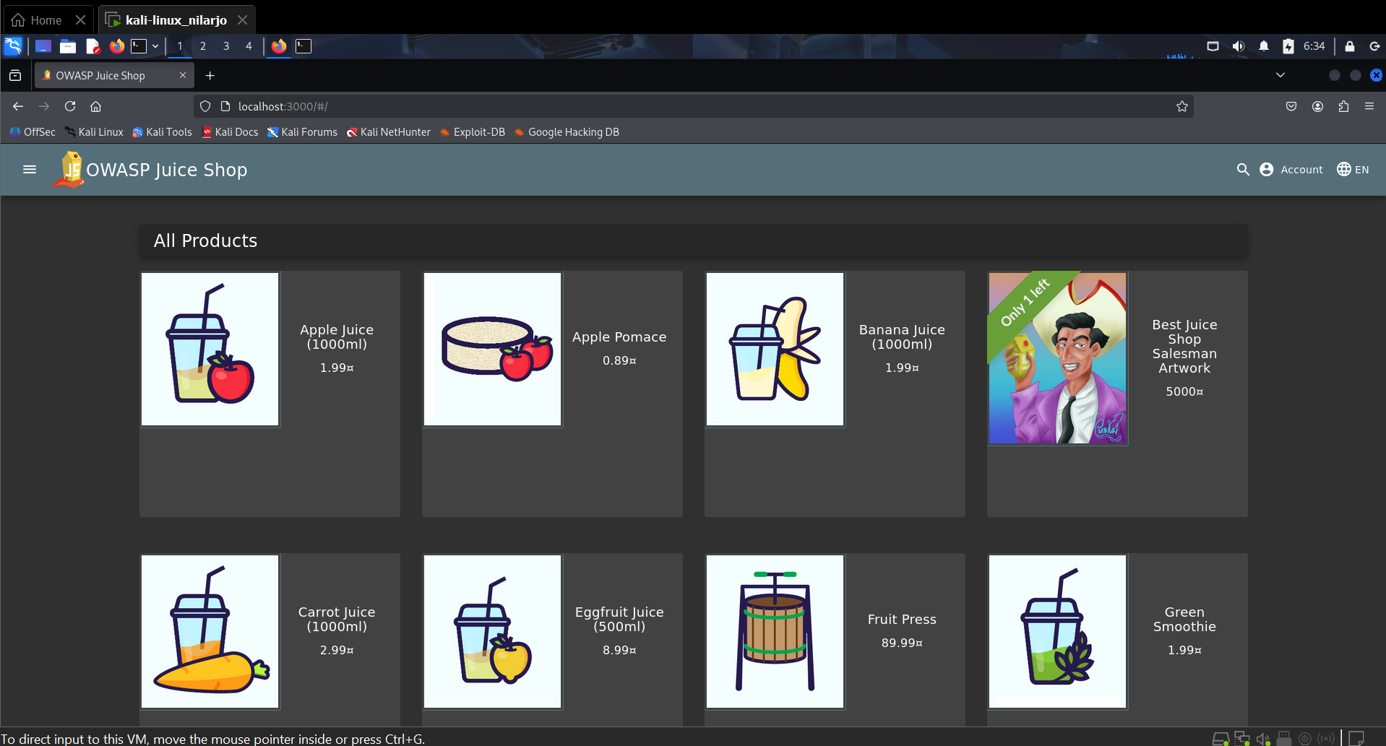
It lists a variety of Juices.
It has an option to log in to an account in the top right corner, and other options throughout the screen to explore.
- As we are focusing on login-related vulnerabilities. I click on the account option in the top right corner of the screen.
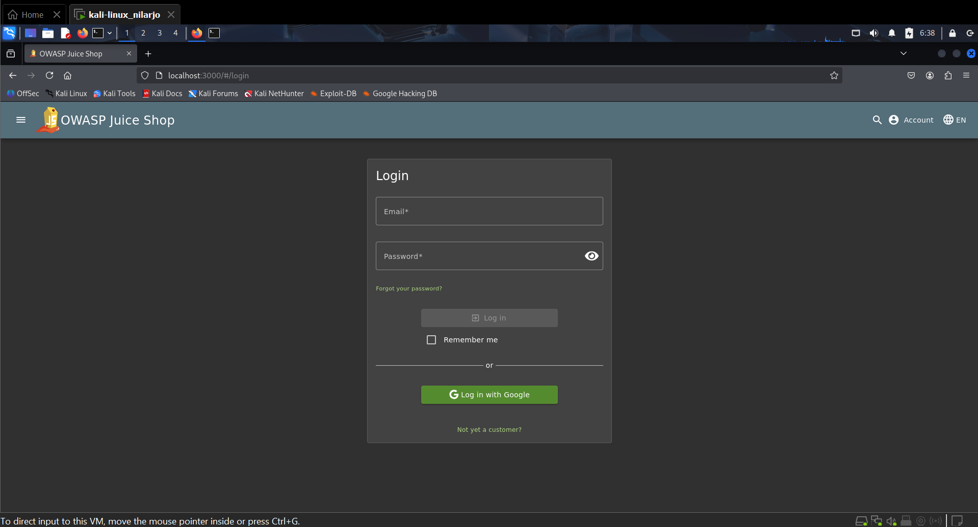
- To find out the usernames, or in this case, the email addresses. I started checking throughout the website.
- I went through a lot of different options, but with no luck. However, I found some after looking through each of the juice items listed and found reviews written through various accounts:
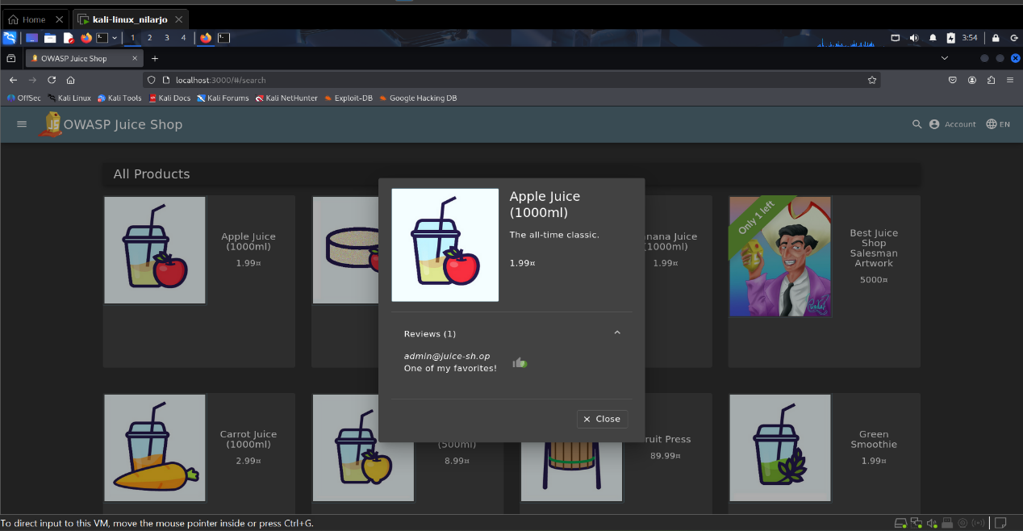
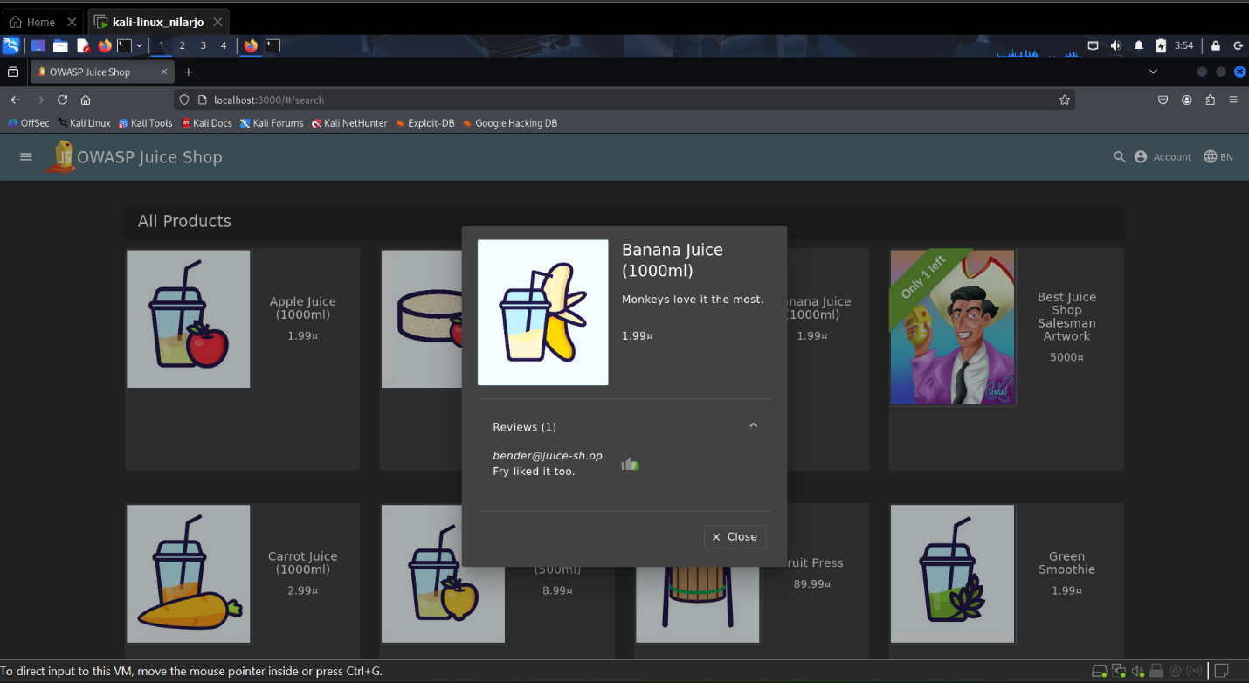
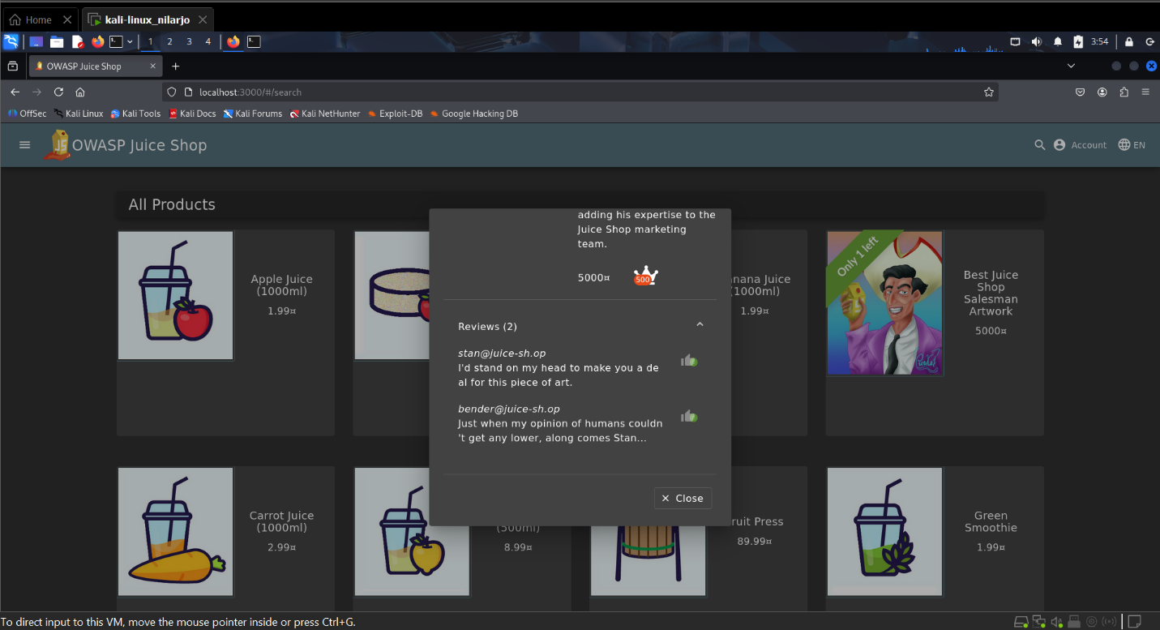
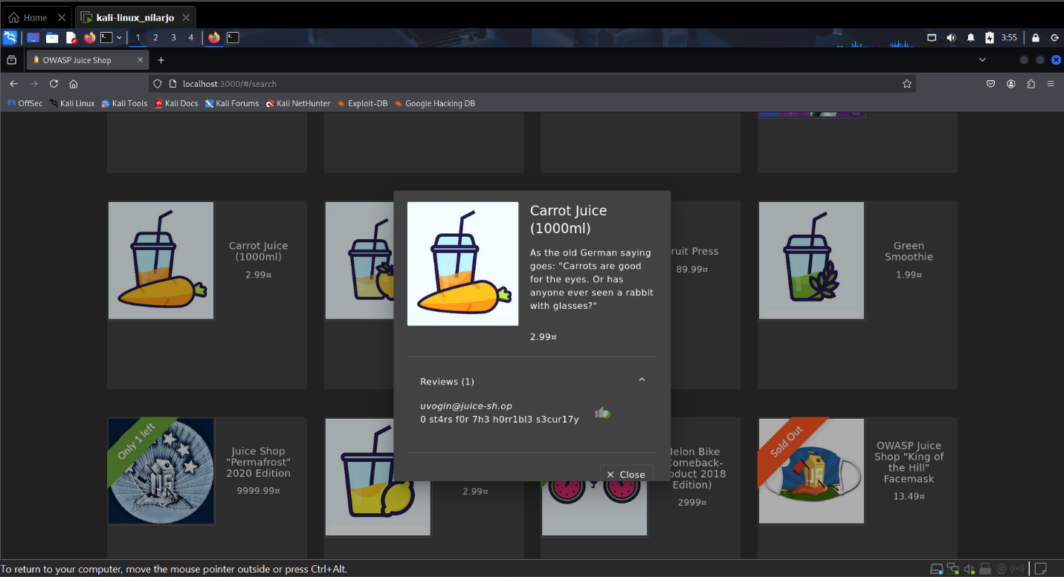
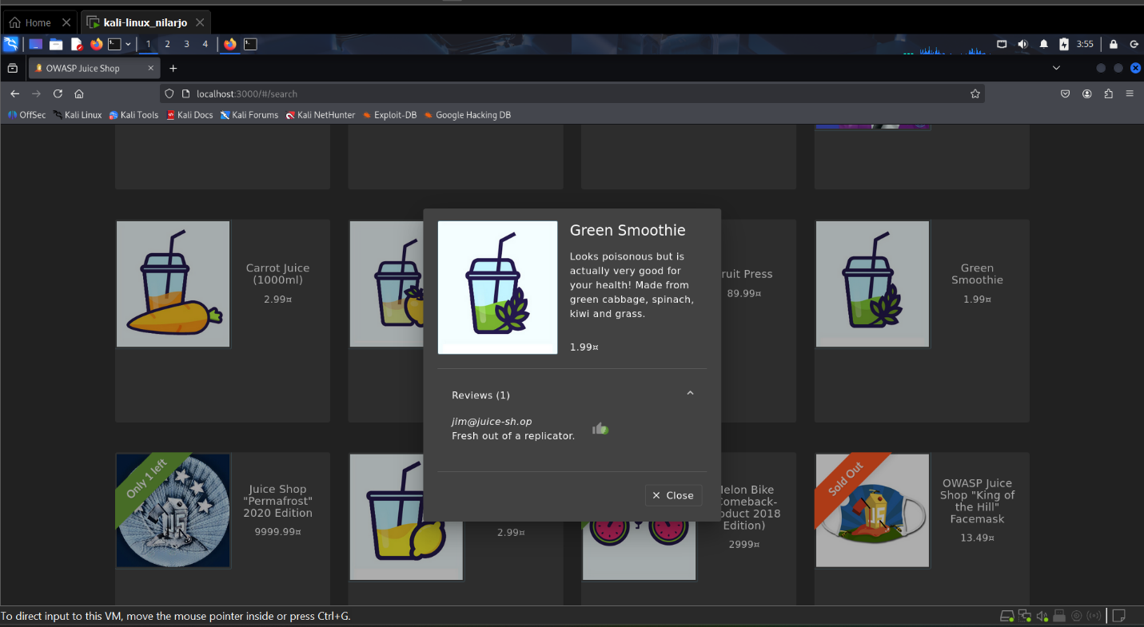
The above screenshots show all the accounts that I could possibly find that have an account.

- Now, if I go to the login page and I use a DQL Injection and replace the login name with the first half of the email. I can easily log in as the user itself, exploiting this vulnerability.
